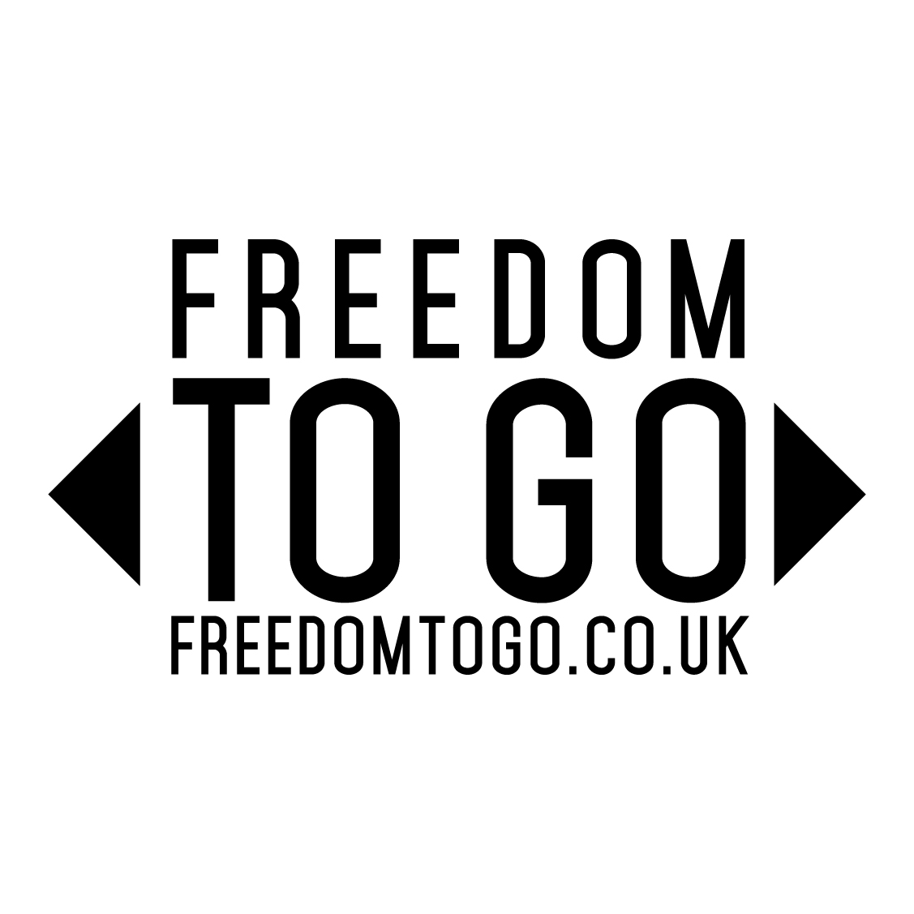
Caravan and motorhome industry to launch perception changing campaign in the UK
London, UK – 19 December 2014 - The NCC (National Caravan Council) has partnered with The Caravan Club and The Camping and Caravanning Club, the UK’s two largest clubs for all forms of camping and caravanning, to launch a joint awareness building campaign to promote the lifestyle benefits of caravan and motorhome holidays.
Designed to attract new audiences to this much-loved style of holiday, ‘Freedom to go’ will draw on the appeal of the great outdoors and the freedom to explore that owning a ‘leisure vehicle’ presents.
Launching in January 2015, the campaign will include a dedicated website (freedomtogo.co.uk), national print and digital advertising and will be supported by a 12 month plan of press activity. “A key objective of the campaign is to decrease the average age of leisure vehicle ownership by five years and get new entrants into the market” said Jennifer Summers, NCC Group Marketing Director. “In order to do that, we aim to turn the perception of camping and caravanning on its head and illustrate the appeal of this type of holiday to modern families and adventurous travellers alike. There hasn’t been a better time to convert more British consumers to this type of holiday and grow the market for all types of leisure vehicle ownership.”
The campaign will showcase beautiful British destinations and unique adventures that touring holidays make possible whilst recommending which type of leisure vehicle will suit individual needs and tastes.
Anthony Trevelyan, Chairman of the Industry Promotional Campaign Working Group said: “I am delighted that the industry is coming together to launch this important initiative. We as an industry have a wonderful offering, it is all about the lifestyle, freedom and exploration. These are the benefits we must communicate effectively through this national campaign.”
Robert Louden, MBE, Director General of The Camping and Caravanning Club said: "The Camping and Caravanning Club is proud to support this new campaign, and we are excited by the opportunities it presents. Camping and caravanning is the perfect way to explore exciting new destinations and we want to help more people enjoy this fabulous pastime and share the same enthusiasm we feel for it.”
Nick Lomas, Director General of The Caravan Club said: “This is an important step the industry is taking. The Caravan Club is delighted to help champion this initiative. Together we have a real opportunity to demonstrate how this fantastic leisure pursuit gives people the freedom to enjoy the great outdoors, visit places large and small throughout the UK and Europe and enjoy more holidays, whether active or relaxing, more often.”
Three leading agencies have been appointed to deliver the campaign. Burn Marketing (Voted UK’s No 1 DM/CRM Agency 2014) and Capella PR (Small Consultancy of the Year 2014) are both London based with digital and web consultants Etch UK (Wirehive 100 top 25 digital agency ) residing in Southampton.
ENDS
The term ‘Leisure vehicle’ encompasses trailer tents, touring caravans, motor homes and campervans. However, the industry also includes caravan holiday homes (commonly called holiday homes or lodges) and camping pods.
The NCC is the trade association for the UK caravan industry, encompassing touring caravans, motorhomes, caravan holiday homes and park homes. The NCC represents some 800 member outlets in manufacturing, park operations, distribution, retailing, and in the provisions of specialist suppliers and services within the UK caravan industry, which is worth in excess of £6 billion per annum (sale of products, services and holiday spend).
The Caravan Club is Europe’s premier touring organisation representing over one million caravanners, motor caravanners and trailer tenters. The Caravan Club has been providing people with the means to enjoy touring holidays since 1907 and offers a wealth of products, information and services, bespoke for caravanners.
The Camping and Caravanning Club is 113-years-old and is the largest and oldest Club in the world for all forms of camping. It has 109 award-winning sites throughout the UK and, through a partnership with the Forestry Commission, now runs and manages a further 16 Camping in the Forest touring sites.
Press contact: Nia Evans - Capella PR – freedomtogo@capellapr.com - 020 7924 5656

